Alhassane Samassekou

ITAI 2376

**Reflective Journal: Module 05 Lab: Exploring Generative AI in Azure AI Foundry**

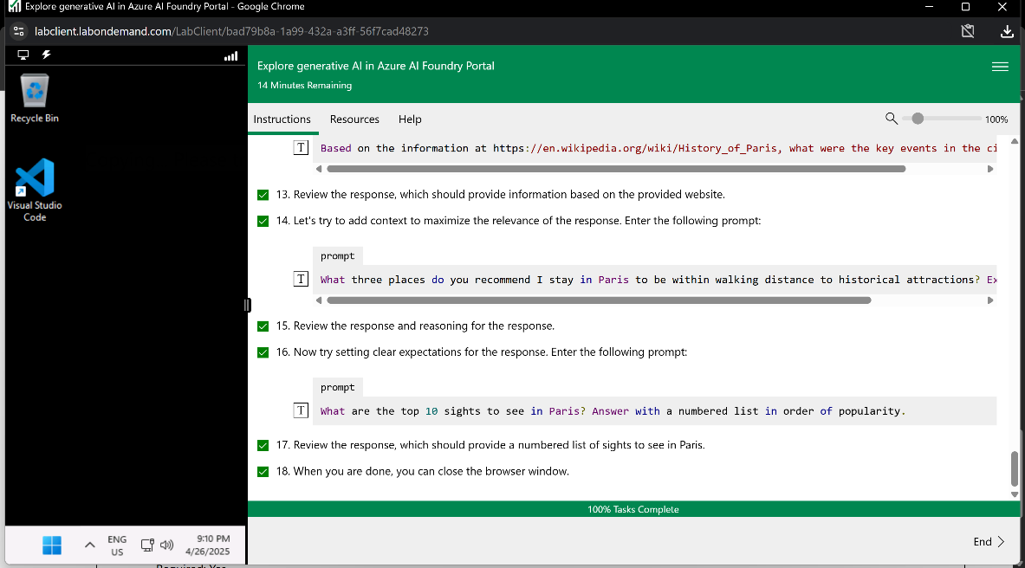

Today’s lab on exploring generative AI in the Azure AI Foundry portal was honestly one of the highlights of this semester. As a second-year AI student, I’m starting to get comfortable with the technical side of things, but this lab pushed me to think more like a developer and a creative problem-solver. It was a guided experience, but the hands-on nature of deploying a model and experimenting with prompts gave me a real sense of ownership over the process.

Logging into the Windows virtual machine and Azure with the provided credentials was straightforward, as I’m used to navigating these environments by now. The setup for creating a project in the Azure AI Foundry portal felt like stepping into a bigger world. Naming the project and hub (project50752050 and hub50752050) and selecting ResourceGroup1 was simple enough, but watching the provisioning of resources like the storage account, key vault, and Azure AI services was a reminder of how complex the backend of AI systems is. It’s one thing to read about cloud infrastructure in lectures, but seeing it come together in real time made me appreciate the layers involved.

The heart of the lab was the Chat playground, where we deployed GPT-4 and experimented with it through a series of prompts about planning a trip to Paris. Deploying the model was a thrill, as it felt like flipping the switch on a powerful machine. I’ve played around with consumer-facing AI like ChatGPT before, but setting up the model myself and configuring it in a professional platform gave me a new perspective. It’s not just about typing a prompt; it’s about understanding the environment the model operates in.

The prompts we used were deceptively simple but taught me a ton about prompt engineering. Starting with a vague request like “Can you help me plan a trip to Paris?” and then refining it to ask for specific dining options or historical insights showed me how much the AI’s output depends on the clarity and context of the input. For instance, grounding the model with a Wikipedia link about Paris’s history produced a more focused response, which tied directly to our class discussions about reducing hallucination through reliable sources. Iterating on prompts to refine results felt like sculpting, as each tweak brought the output closer to what I wanted.

One challenge I ran into was the model deployment process. It took longer than I expected, and the interface didn’t give clear feedback on progress. I had to navigate to the Models and Endpoints section to confirm it was working, which was a bit frustrating. This hiccup taught me to be proactive in troubleshooting, a skill I’m sure will come in handy for bigger projects.

The biggest insight I gained was how much control we have when we’re the ones building the AI experience. As a user, I’d never thought about the infrastructure or deployment choices behind a chatbot, but as a developer, I saw how every decision, from resource provisioning to prompt design, shapes the final product. It’s empowering but also a little daunting to think about the responsibility that comes with it, especially when you consider how AI outputs can influence people’s decisions.

This lab struck a great balance between technical skills and creative exploration. It showed me that generative AI is becoming more accessible, but mastering it requires understanding both the tools and the principles behind them. I’m excited to dig deeper into Azure and maybe even try building my own AI application next time. For now, I’m just stoked to have gotten a taste of what it’s like to wield these tools as a creator, not just a consumer.